Clean Code Principles - Refactor Often
# Source: AI Source: Provided by: [Data Path: Persons Table -> ID Column: 1, Name_En Column: Motasem Essam] -> From: [Chatgpt (GPT‑5 Mini)] on [12/9/2025]
Refactoring means improving the internal structure of your code without changing its behavior.
The goal is to keep code clean, readable, and maintainable over time.

🔑 Why Refactor Often?
# Source: AI Source: Provided by: [Data Path: Persons Table -> ID Column: 1, Name_En Column: Motasem Essam] -> From: [Chatgpt (GPT‑5 Mini)] on [12/9/2025]
- Prevents code from becoming messy (“code rot”)
- Improves readability and design
- Makes future changes easier and safer
- Helps apply other clean code principles (SRP, DRY, KISS)

✅ Good Example (Refactored Code)
# Source: AI Source: Provided by: [Data Path: Persons Table -> ID Column: 1, Name_En Column: Motasem Essam] -> From: [Chatgpt (GPT‑5 Mini)] on [12/9/2025]
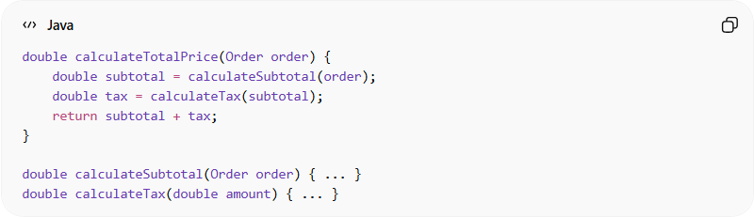
double calculateTotalPrice(Order order) {
double subtotal = calculateSubtotal(order);
double tax = calculateTax(subtotal);
return subtotal + tax;
}

double calculateSubtotal(Order order) { ... }
double calculateTax(double amount) { ... }
👉 Clean, modular, and easy to understand

❌ Bad Example (Not Refactored)
# Source: AI Source: Provided by: [Data Path: Persons Table -> ID Column: 1, Name_En Column: Motasem Essam] -> From: [Chatgpt (GPT‑5 Mini)] on [12/9/2025]
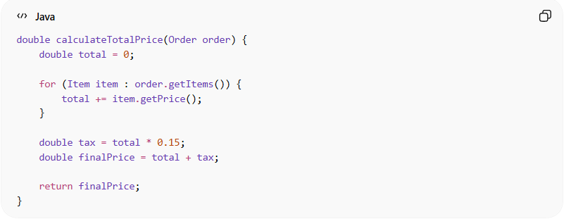
double calculateTotalPrice(Order order) {
double total = 0;

for (Item item : order.getItems()) {
total += item.getPrice();
}

double tax = total * 0.15;
double finalPrice = total + tax;

return finalPrice;
}
👉 Works fine, but:
- Everything is in one place
- Harder to reuse logic
- Harder to test individual parts

🔄 Another Example (Before vs After)
# Source: AI Source: Provided by: [Data Path: Persons Table -> ID Column: 1, Name_En Column: Motasem Essam] -> From: [Chatgpt (GPT‑5 Mini)] on [12/9/2025]
❌ Before Refactoring
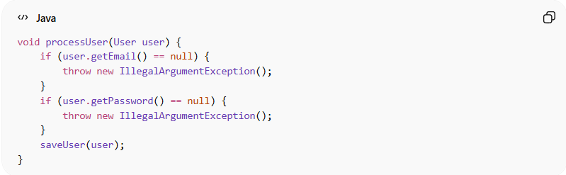
void processUser(User user) {
if (user.getEmail() == null) {
throw new IllegalArgumentException();
}
if (user.getPassword() == null) {
throw new IllegalArgumentException();
}
saveUser(user);
}
✅ After Refactoring
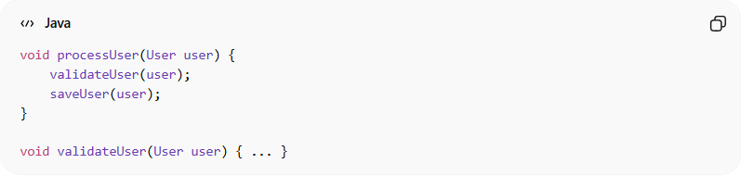
void processUser(User user) {
validateUser(user);
saveUser(user);
}

void validateUser(User user) { ... }

💡 Key Idea
# Source: AI Source: Provided by: [Data Path: Persons Table -> ID Column: 1, Name_En Column: Motasem Essam] -> From: [Chatgpt (GPT‑5 Mini)] on [12/9/2025]
Refactoring is not a one-time task—it should happen continuously during development.

🚫 Common Mistakes
# Source: AI Source: Provided by: [Data Path: Persons Table -> ID Column: 1, Name_En Column: Motasem Essam] -> From: [Chatgpt (GPT‑5 Mini)] on [12/9/2025]
- Ignoring messy code and leaving it “for later”
- Refactoring without tests (risky)
- Over-refactoring (changing too much unnecessarily)

🧪 Best Practices
# Source: AI Source: Provided by: [Data Path: Persons Table -> ID Column: 1, Name_En Column: Motasem Essam] -> From: [Chatgpt (GPT‑5 Mini)] on [12/9/2025]
- Refactor in small steps
- Always keep code working after each change
- Write tests before refactoring when possible
- Refactor when:
  - You see duplication
  - A function becomes too long
  - Code becomes hard to understand

🧾 Summary
# Source: AI Source: Provided by: [Data Path: Persons Table -> ID Column: 1, Name_En Column: Motasem Essam] -> From: [Chatgpt (GPT‑5 Mini)] on [12/9/2025]
Refactoring helps you:
- Maintain clean and high-quality code
- Reduce technical debt
- Improve design over time
- Make your code easier to extend and modify

